**AP PHYSICS C – HOMEWORK 6, MOMENTUM & CENTER OF MASS (due 11/17-18/2014)  
(Show work and answers on other sheets of paper to turn in)**

1. The figure below has a uniform mass density. Find its center of mass.

2 m 2 m

4m

6 m

6 m

1. Find the center of mass (x coordinate) of a club of length L with a density (mass per unit length) of λ = λ0(1 + x/L), where x is the distance from the small end of the club.
2. Two 5 kg masses have velocities of 4 m/s East and 10 m/s at 30° North of East. Find the magnitude and direction of the velocity of the center of mass.
3. A puck of mass .5 kg collides with a second, stationary puck of the same mass. The initial speed of the first puck is 5 m/s. After the collision, one puck leaves with a velocity of v1 at 30° above the original line of motion, while the second puck leaves with speed of v2 at 60° below the original line of motion.
   1. Calculate v1 and v2.
   2. Was the collision elastic?
4. A 10 kg projectile is launched with an initial velocity of 100 m/s at an angle of 60° above the horizontal. At the highest point, the projectile explodes into two pieces of masses 4 kg and 6 kg. The 6 kg fragment lands 100 m past the point directly below where the projectile exploded 3 seconds after the explosion.
   1. Determine the velocity of the 4 kg fragment immediately after the explosion.
   2. Find the distance between the original launch point and where the 4 kg fragment hits the ground.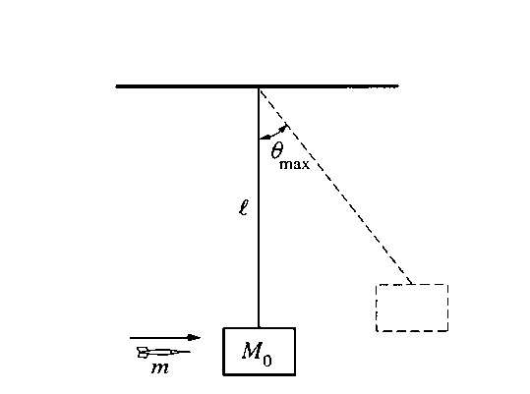
5. In an experiment, you wish to determine the speed of a dart just after it leaves a dart gun. The dart, of mass m, is fired with the gun very close to a wooden block of mass M0 which hangs from a cord of length l and negligible mass, as shown above. Assume the size of the block is negligible compared to l, and the dart is moving horizontally when it hits the left side of the block at its center and becomes embedded in it. The block swings up to a maximum angle from the vertical. Express your answers to the following in terms of m, M0, l, θmax, and g.
   1. Determine the speed v0 of the dart immediately before it strikes the block.
   2. The dart and block subsequently swing as a pendulum. Determine the tension in the cord when it returns to the lowest point of the swing.
6. A ball of mass .5 kg is thrown horizontally against a wall at 10 m/s and rebounds at the same speed.
   1. What is the magnitude of the impulse on the ball?
   2. If the ball is in contact with the wall for .002 s, what is the average force exerted by the wall on the ball?
7. Beads, each with a mass of .5 g, roll off a flat table at rate of 100 beads per second. The beads fall a distance of .5 m onto a scale and then bounce back to their original height. What does the scale read (on average)?
8. A swing seat of mass M is connected to a fixed point P by a massless cord of length L. A child also of mass M sits on the seat and begins to swing with zero velocity at a position at which the cord makes a 60° angle with the vertical is shown in Figure I. The swing continues down until the cord is exactly vertical at which time the child jumps off in a horizontal direction. The swing continues in the same direction until its cord makes a 45° angle with the vertical as shown in Figure II: at that point it begins to swing in the reverse direction. With what velocity relative to the ground did the child leave the swing?

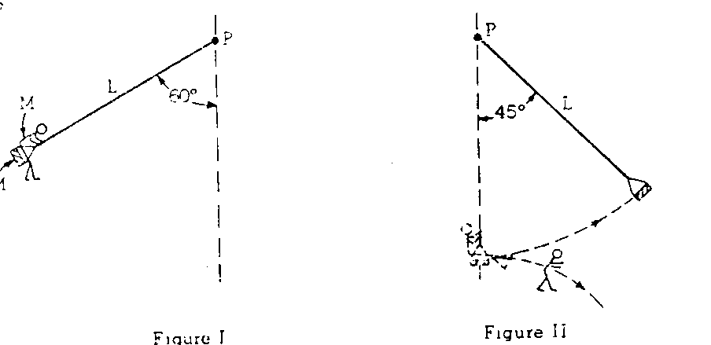

1. A gun and a wooden block are firmly attached to opposite ends of a board that is free to slide on a frictionless surface. Beginning at rest, the gun is fired, and a bullet is imbedded in the block. The mass of the gun is Mg = 1 kg, the mass of the bullet is Mb = .02 kg, the mass of the block is Mw = 10 kg, and the mass of the board is 5 kg. If the gun and block are initially L = 1m apart, the bullet leaves the gun with a velocity of vb = 200 m/s, the fall of the bullet is negligible, and the bullet’s penetration into the block (d = .04 meters) is small,
   1. What is the velocity of the board after the gun is fired but before the bullet is imbedded in the block?
   2. What is the velocity of the cart after the bullet is comes to rest in the block?
   3. About how far has the block moved when the bullet comes to rest in the block?
   4. What is the approximate average force exerted by the block on the bullet (you can assume the bullet is accelerated by the block at a roughly constant rate)?
2. An object of mass 2 kg starts at rest at t = 0. Using the graph below, find the impulse in first 8 s and final speed.